**Assignment 4**

Connect to EC2 instance using the pem file and the public IPv4 DNS

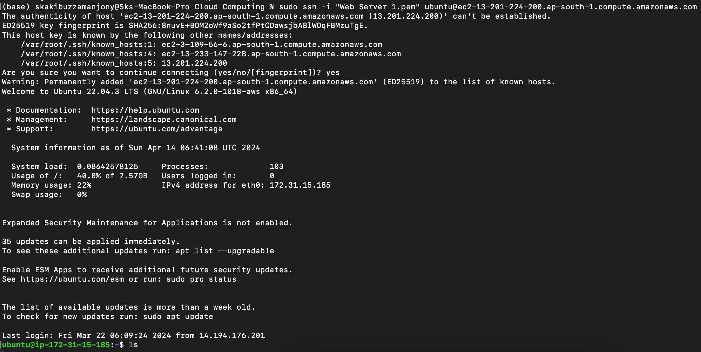

Install apche using these two commands

sudo apt update

sudo apt install apache2

Go to the public IPv4 address of the ec2 instance and if something like this shows up the apache has been seccessfully installed

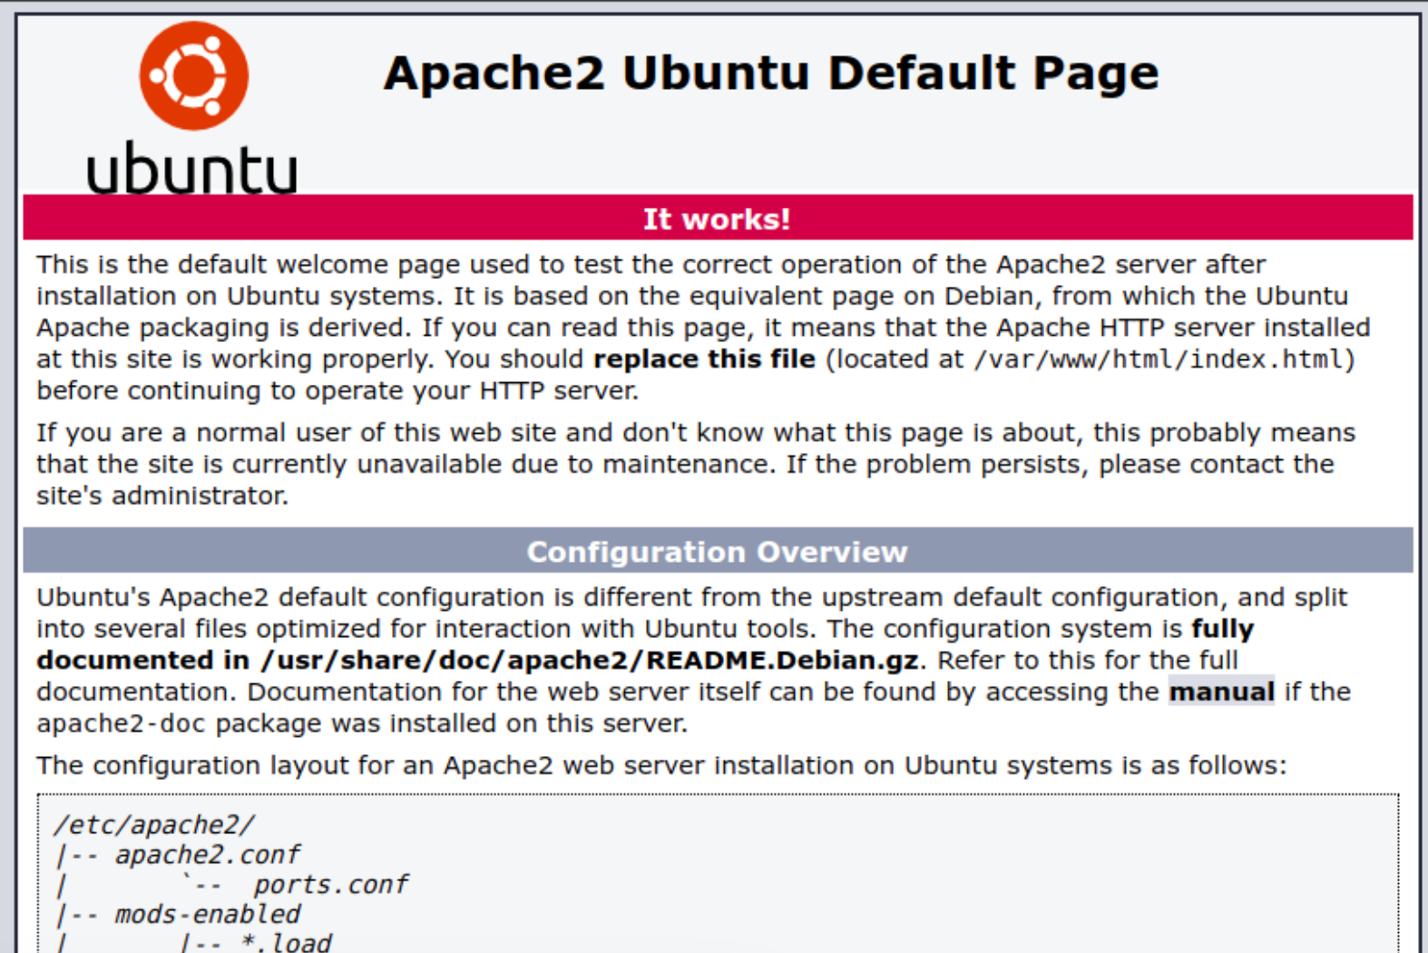

from the terminal go **/var/www/html**

and locate **index.html** file

then give command to modify the contents

sudo nano index.html

after opening the gnu nano interface delete the existing html code and paste this

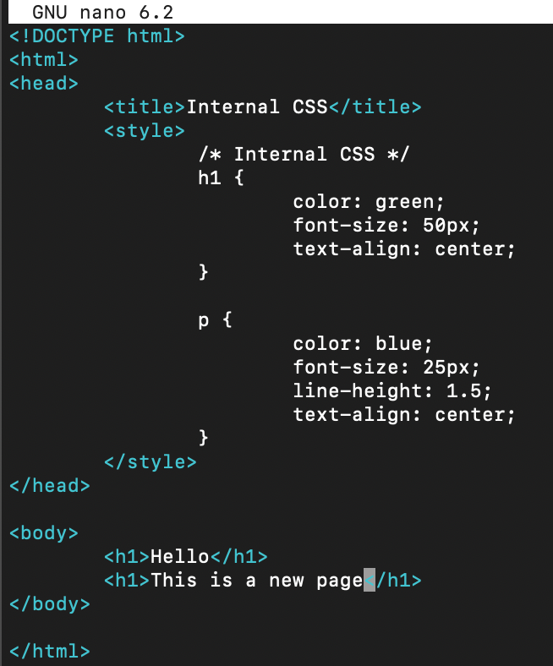

to save the modified file press **control+x** then press **y** then press **Enter**

then do the public IPv4 address to see the changes

